Using the Visibility Chart to Determine if your Asteroid is Observable
So you want to observe an asteroid and you know its name. You are ready to submit an observation.
- Click “Add New Observation”.
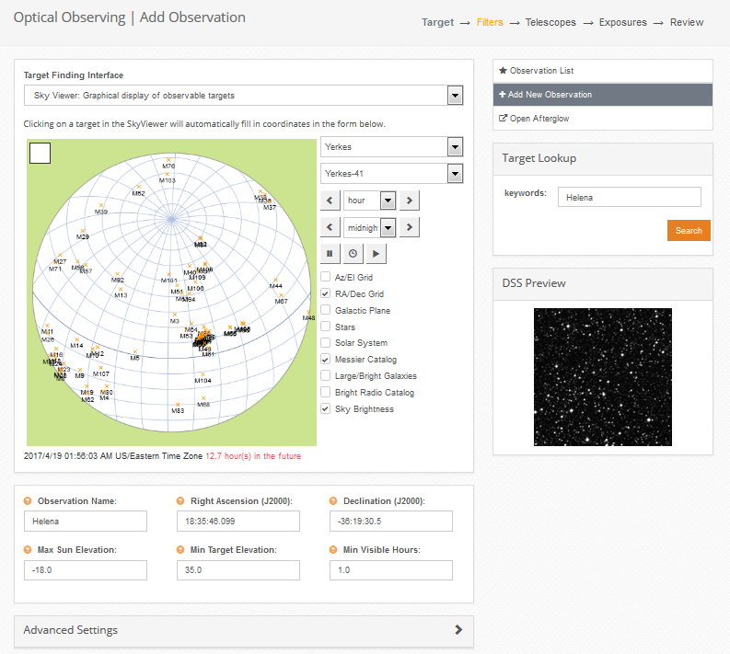
2. Search for the asteroid in the Target Lookup box. If Skynet knows the name of your asteroid, you will get a result.

3. Make sure your asteroid rises high enough in the sky for you to get good steady images. Change the “Minimum Telescope Elevation” to 35 degrees.

4. Notice the observatories that show the visibility curve above the Minimum Telescope Elevation horizontal cut-off line. Those observatories can see your object. If none of the visibility curves are above the cutoff line, choose a different asteroid.
Lowering the Minimum Telescope Elevation could result in poor quality images because your object(s) are being observed through a lot of atmosphere, or air mass. If your object is visible high in the sky, you can even increase the Minimum Telescope Elevation. In the example above, with the asteroid Helena, you could raise the elevation to 50 degrees so the images are taken through less air mass.

