Finding Asteroids and Comets to Observe.

Hi everybody. I’ve been having a lot of fun learning how to observe asteroids. I hope you will too! Here are some things I’ve learned. Happy Asteroid Hunting!

Vivian

I like to start at skynetjuniorscholars.org, and make a note in my notebook about what I plan to do. You can keep adding notes in your notebook whenever you wish. It’s nice to be able to look back at your notes when you are describing your project.

If you know the name of the asteroid or comet you want to observe already, you can type it into the search box on the “Add an Optical Observation” link in My Observatory.

But, if you are looking for an asteroid to observe you can search for one on the Jet Propulsion Laboratory’s What’s Observable page: http://ssd.jpl.nasa.gov/sbwobs.cgi

You will need to adjust three settings on the What’s Observable page:
- Observation Time
- Observer Location
- Observer Constraints
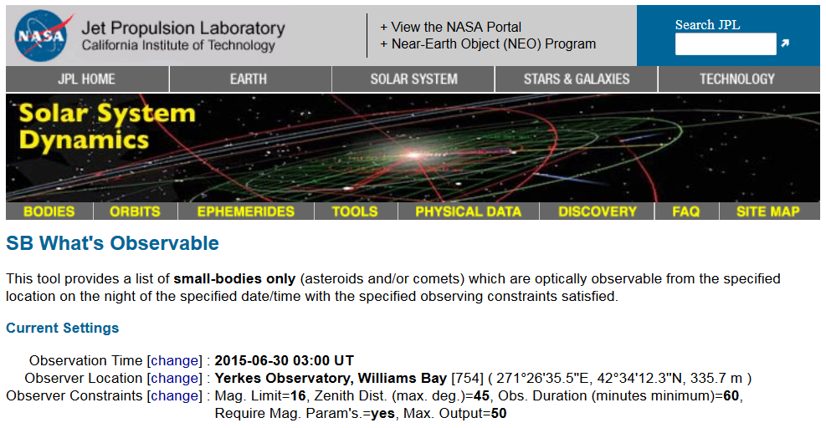

Observation Time: Click on [change]. First set to the Current Time to get close to the right time. Then enter a time when it will be dark at the telescope, and click “Use Specified Time”.
The following table should help you pick the time when it will be night at the observatory/telescope you choose. Find your season and the telescope and read the UT dark time range in the box.

Table 1: Dark time range for each observatory (Universal Time or UT)
CODE & OBSERVATORY | SPRING MARCH 19 | SUMMER  JUNE 20 | FALL  SEPT. 23 | WINTER  DEC. 21
754 YERKES | 02:00-10:00 | 03:00-09:00 | 01:00-10:00 | 00:00-11:00
323 RCOP at Perth | 12:00-21:00 | 11:00-22:00 | 12:00-21:00 | 13:00-19:00
807 PROMPT at CTIO | 01:00-09:00 | 00:00-10:00 | 00:00-09:00 | 01:00-08:00
Q61 PROMPT at SSO | 10:00-19:00 | 09:00-19:00 | 09:00-18:00 | 11:00-17:00
W38 DSO | 01:00-10:00 | 03:00-08:00 | 01:00-10:00 | 00:00-11:00
H21 ARO | 02:00-10:00 | 03:00-09:00 | 01:00-10:00 | 00:00-11:00
U54 GORT at HUME | 04:00-12:00 | 05:00-11:00 | 03:00-12:00 | 02:00-13:00
AUGO/AURT | 04:00-12:00 | 05:00-11:00 | 03:00-12:00 | 02:00-13:00
G52 Stone Edge  (Operate remotely) | 04:00-12:00 | 05:00-11:00 | 03:00-12:00 | 02:00-13:00

Note: Astronomers use “Universal Time” so that they don’t have to describe their local time zones to astronomers in other parts of the world. Universal Time is the local time on the Prime Meridian in Greenwich England!

Observer Location: Click on [change]. Type in the Observatory Code for the Skynet Telescope you want to use.

Observer Constraints: Click on [change]. Here are some suggestions
- Limit number of matches to: unlimited
- 16 Visual Magnitude Limit
- 45 Maximum Zenith Distance (degrees from the highest point in the sky)
- 60 Minimum Observable Duration (minutes)
- Check the box for Object Magnitude Parameters Required
- Click “Use Specified Settings”

Finally, click “Find Observable Objects.” If all goes well, you will get a list like the one below! Note: Visual Magnitude means apparent brightness, larger numbers are dimmer, smaller numbers are brighter. Yerkes and PROMPT telescopes can image objects as dim as 18th magnitude in less than a minute with a clear filter! So don’t select the brightest asteroid to observe! We suggest that you select objects around 12, 13, 14, 15, or 16 magnitudes. It is better to choose dimmer asteroids so there are plenty of stars in the field and the asteroid is more or less a similar brightness to those stars.

Select an Asteroid from the list. Return to Skynet and Add an Observation. Type your Asteroid in the search box, and check the Target Visibility Graph to confirm that your asteroid is high in the sky at night on your Skynet Telescope.

