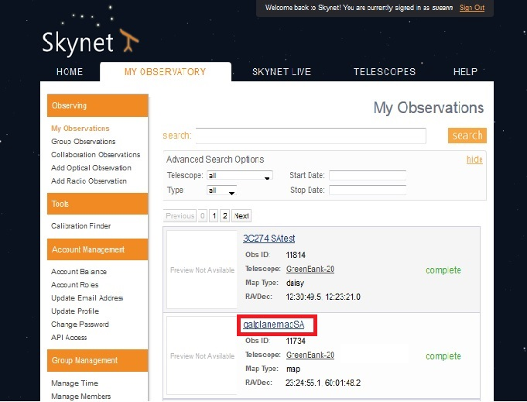
You can now access your radio images from Skynet directly. Here’s how.
"My Observatory" on Skynet
You have taken some data with the 20 Meter radio telescope. You see completed observations on “My Observatory”:
Note that radio observations show no previews.
But, if you click on the observation name (such as the one I’ve highlighted with a red box), you will be taken to the next page below.

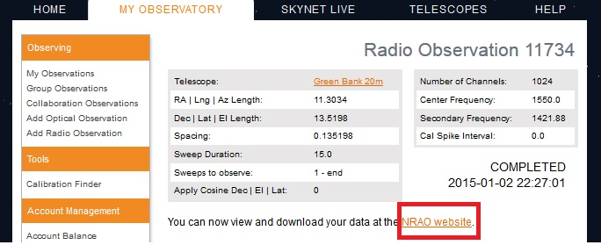
My Observation Page
And, if you click on the link: “NRAO website”, you will be taken directly to your data on the NRAO Data Page- no need to hunt though a huge list!!! The next image below is a screen shot of the NRAO data page.

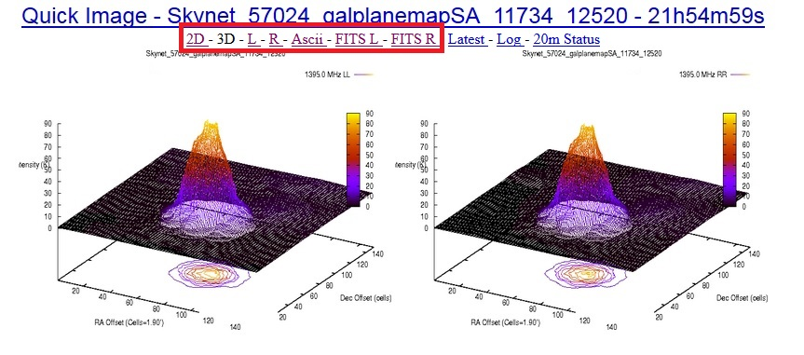
NRAO Data Page
On the NRAO Data Page, the links outlined in red take you to different representations of the data. The “20m Status” link takes you back to Skynet.

